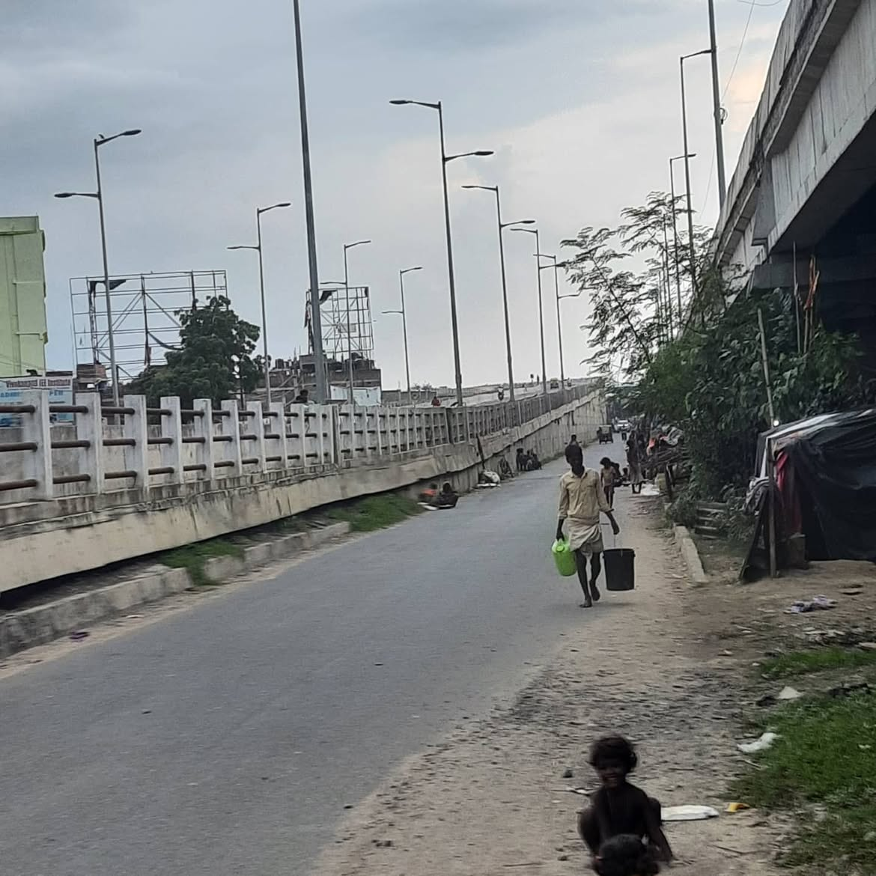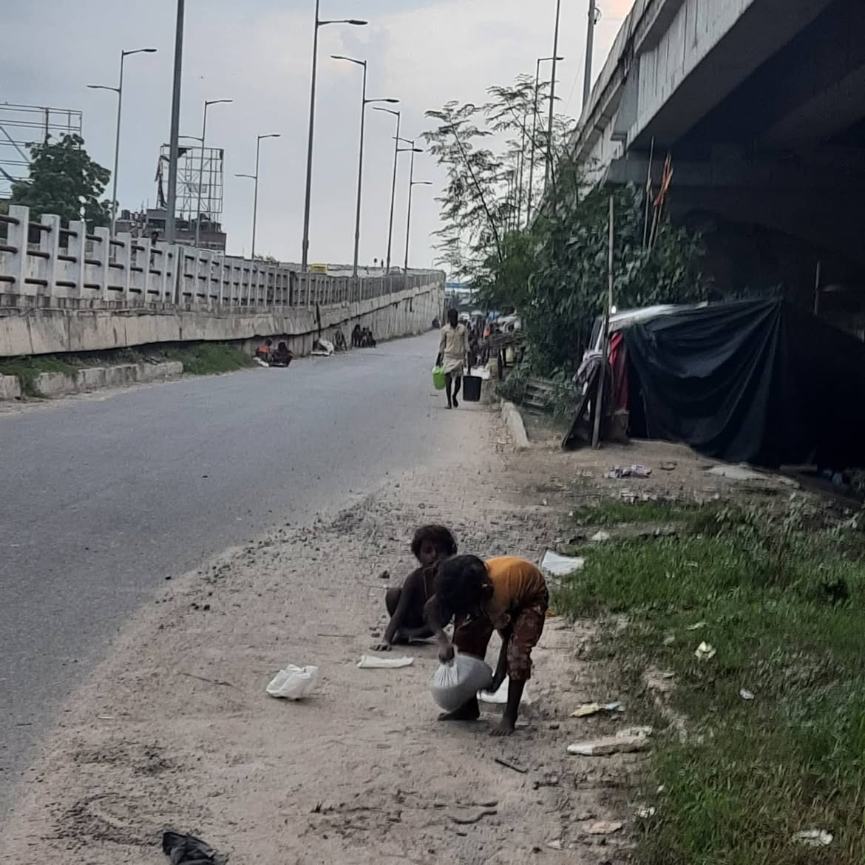

The kids are happy,
oblivious to their own reality,
unaware of what the future holds for them,
unaware of social disparities,

The kids are happy,
happy to be under God's protection,
feeling no need to protect God itself,
to safeguard their bourn identity,

The kids are happy,
vulnerable, and protected,
with a false sense of control,
making playgrounds out of wide roads,
assigning to each other,
tags, labels and roles,

The kids are happy
till one gets hit by a car,
the other will get traumatized,
and then protests will start,
Those in power will blame the parents,
"It is your fault that you live beside a sewer, and let your kids play on stones and tar"

The kids are happy,
till they're scarred,
we're all kids, to different degrees,
till recognizing our privileges, we start.

